Easyvisa
Business Report

Classification Model Coded Project
By
Rajesh Mambulli

Table of Contents
Classification Model Coded Project 1
1. Context 6
2. Objective 6
3. Data Dictionary 7
4. Data Overview through Python 7
4.1 Checking for missing values in the data. 8
4.2 Checking for duplicate values in the data. 9
4.3 Checking the statistical summary of the data. 9
5.0 Univariate Analysis 10
5.1 Observations on no_of_employees 10
5.2 Observations on prevailing_wage 11
5.3 Observations on continent 12
5.4 Observations on education_of_employee 13
5.5 Observations on has_job_experience 14
5.6 Observations on requires_job_training 15
5.6 Observations on region_of_employment 16
5.7 Observations on unit_of_wage 17
5.8 Observations on full_time_position 18
5.9 Observations on case_status 19
6.0 Bivariate Analysis 20
6.1 Observations on case_status vs continent 21
6.2 Observations on case_status vs education_of_employee 22
6.3 Observations on case_status vs has_job_experience 23
6.4 Observations on case_status vs requires_job_training 24
6.5 Observations on case_status vs no_of_employees 25
6.5 Observations on case_status vs yr_of_estab 26
6.5 Observations on case_status vs region_of_employment 27
6.6 Observations on case_status vs prevailing_wage 28
6.7 Observations on case_status vs unit_of_wage 29
6.8 Observations on case_status vs full_time_position 30
7.0 Data Preprocessing 31
7.1 Feature Engineering 31
7.2 Checking for Outliers 31
7.3 Data Split into Train, Validation, Test sets. 32
7.4 Encoding Categorical variables. 32
8.0 Model Building 32
8.1 Model Performance – Original Data 33
8.2 Model Performance – Oversampled Data 34
8.3 Model Performance – Undersampled Data 35
8.4 Model Choosing Stage for Hyperparameter Tuning 36
9.0 Hyperparameter Tuning 36
9.1 Tuning Ada Boost Classifier model with Original data 36
9.2 Tuning Gradient Boosting classifier model with Original data 36
9.3 Tuning Gradient Boosting classifier model with Oversampled data 37
10.0 Model Comparison and Final Model Selection 37
10.1 Training data Performance Comparison 37
10.2 Validation data Performance Comparison 38
10.3 Test data Performance Comparison using selected Model 38
11.0 Feature Importance 39
12.0 Business Insights and Recommendations 40

Table of Figures
Figure 1: First 5 rows of dataset 7
Figure 2: Shape of the data 7
Figure 3: Data Types of attributes 8
Figure 4: No. of Missing values in the data 8
Figure 5: No. of Duplicate values in data 9
Figure 6: Statistical Summary of data 9
Figure 7: Box and Distribution plot 10
Figure 8: Box and Distribution plot 11
Figure 9: Count plot of continent attribute 12
Figure 10: Count plot of education_of_emplyoee 13
Figure 11: Count plot of attribute 14
Figure 12: Count plot of attribute 15
Figure 13: Count plot of attribute 16
Figure 14: Count plot of attribute 17
Figure 15: Count plot of attribute 18
Figure 16: Count plot of attribute 19
Figure 17: Heatmap of attributes 20
Figure 18: Count plot of attributes 21
Figure 19: Count plot of attributes 22
Figure 20: Count plot of attributes 23
Figure 21: Count plot of attributes 24
Figure 22: Box and Distribution plot of attributes 25
Figure 23: Box and Distribution plots of attributes 26
Figure 24: Count plot of attributes 27
Figure 25: Box and Distribution plots of attributes 28
Figure 26: Count plot of attributes 29
Figure 27: Count plot of attributes 30
Figure 28: education of employee feature engineering 31
Figure 29: Adding a derived feature. 31
Figure 30: Checking for outliers 31
Figure 31: Data split 32
Figure 32: One hot encoding of categorical variables 32
Figure 33: Training data and Validation data Performance on Original Data 33
Figure 34: Difference between Performances 33
Figure 35: Oversampled Data Shape and Description 34
Figure 36: Training data and Validation data Performance on Oversampled Data 34
Figure 37: Difference between Performances 34
Figure 38: Undersampled Data Shape and Description 35
Figure 39: Training data and Validation data Performance on Undersampled Data 35
Figure 40: Difference between Performances 35
Figure 41: Tuned Model Performance on Training data 36
Figure 42: Tuned Model Performance on Validation data 36
Figure 43: Tuned Model Performance on Training data 36
Figure 44: Tuned Model Performance on Validation data 37
Figure 45: Tuned Model Performance on Training data 37
Figure 46: Tuned Model Performance on Validation data 37
Figure 47: Model Comparison on Training Data 37
Figure 48: Model Comparison on Validation Data 38
Figure 49:Final Performance on Test Data 38
Figure 50: Feature Importance 39

Context
Business communities in the United States are facing high demand for human resources, but one of the constant challenges is identifying and attracting the right talent, which is perhaps the most important element in remaining competitive. Companies in the United States look for hard-working, talented, and qualified individuals both locally as well as abroad.
The Immigration and Nationality Act (INA) of the US permits foreign workers to come to the United States to work on either a temporary or permanent basis. The act also protects US workers against adverse impacts on their wages or working conditions by ensuring US employers' compliance with statutory requirements when they hire foreign workers to fill workforce shortages. The immigration programs are administered by the Office of Foreign Labor Certification (OFLC).
OFLC processes job certification applications for employers seeking to bring foreign workers into the United States and grants certifications in those cases where employers can demonstrate that there are not sufficient US workers available to perform the work at wages that meet or exceed the wage paid for the occupation in intended employment.

Objective
In FY 2016, the OFLC processed 775,979 employer applications for 1,699,957 positions for temporary and permanent labour certifications. This was a nine percent increase in the overall number of processed applications from the previous year. The process of reviewing every case is becoming a tedious task as the number of applicants is increasing every year.

The increasing number of applicants every year calls for a Machine Learning based solution that can help in shortlisting the candidates having higher chances of VISA approval. OFLC has hired the firm EasyVisa for data-driven solutions. You as a data scientist at EasyVisa must analyse the data provided and, with the help of a classification model:

- Facilitate the process of visa approvals.
- Recommend a suitable profile for the applicants for whom the visa should be certified or denied based on the drivers that significantly influence the case status.

Data Dictionary
The data contains the different attributes of the employee and the employer. The detailed data dictionary is given below.
- case_id: ID of each visa application
- continent: Information of continent the employee
- education_of_employee: Information of education of the employee
- has_job_experience: Does the employee has any job experience? Y= Yes; N = No
- requires_job_training: Does the employee require any job training? Y = Yes; N = No
- no_of_employees: Number of employees in the employer's company
- yr_of_estab: Year in which the employer's company was established
- region_of_employment: Information of foreign worker's intended region of employment in the US.
- prevailing_wage: Average wage paid to similarly employed workers in a specific occupation in intended employment. The purpose of the prevailing wage is to ensure that the foreign worker is not underpaid compared to other workers offering the same or similar service in the same area of employment.
- unit_of_wage: Unit of prevailing wage. Values include Hourly, Weekly, Monthly, and Yearly.
- full_time_position: Is the position of work full-time? Y = Full-Time Position; N = Part-Time Position
- case_status: Flag indicating if the Visa was certified or denied

Data Overview through Python
Data which is stored in csv file is imported to Jupyter Notebook with the help of pandas, NumPy libraries and used matplotlib and seaborn libraries to help with data visualization. Dataset is stored in python variable named data.
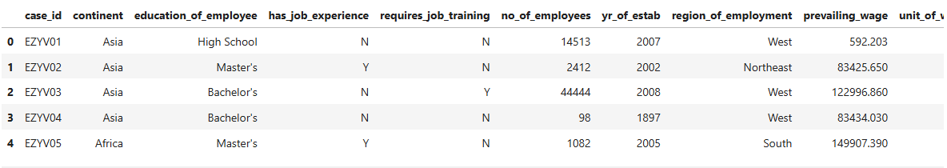
Figure 1: First 5 rows of dataset
The dataset has 25480 rows and 12 columns.
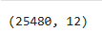
Figure 2: Shape of the data

Checking the data types of data.
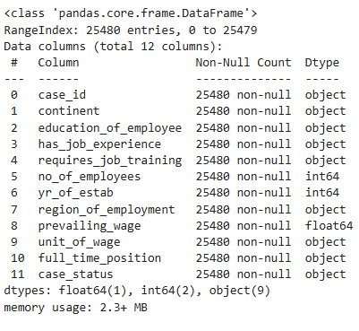
Figure 3: Data Types of attributes

Checking for missing values in the data.
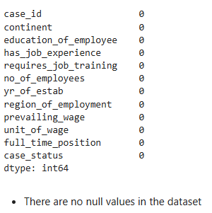
Figure 4: No. of Missing values in the data

Checking for duplicate values in the data.
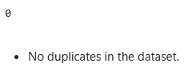
Figure 5: No. of Duplicate values in data

Checking the statistical summary of the data.
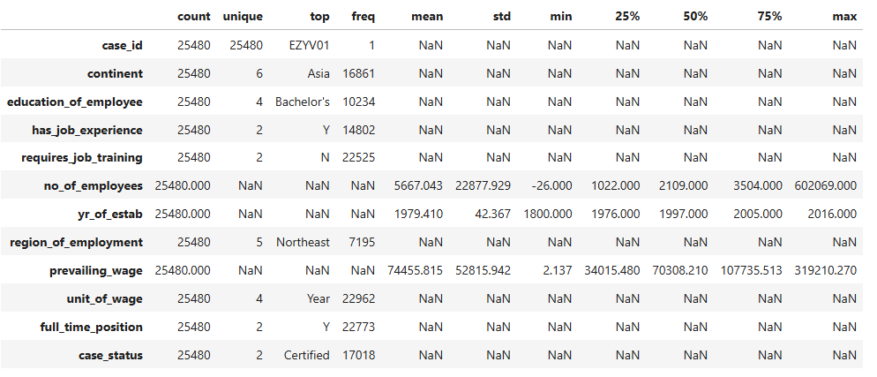
Figure 6: Statistical Summary of data

- Case ID: This represents a unique identifier for each case. There are 25,480 cases, each with a unique identifier.
- Continent: The continent where the employment is located. There are 6 unique continents represented in this dataset. Asia has the highest frequency with 16,861 cases.
- Education of Employee: This indicates the highest education level attained by employees. There are 4 unique education levels recorded, with a Bachelor's degree being the most common (10,234 cases).
- Has Job Experience: This indicates whether employees have prior job experience. There are 2 unique responses (Yes or No). The majority, 14,802 cases, have job experience (Yes).
- Requires Job Training: This indicates whether the job requires any training. There are 2 unique responses (Yes or No). Most jobs do not require training, with 22,525 cases indicating No.
- Number of Employees: This represents the number of employees in the company. The dataset has 25,480 entries with the number of employees ranging from -26 to 602,069. The average number of employees is approximately 5,667, with a standard deviation of 22,877. The 25th percentile is at 1,022, the median is 2,109, and the 75th percentile is at 3,504.
- Year of Establishment: This represents the year the company was established. There are 25,480 entries with years ranging from 1800 to 2016. The average year of establishment is around 1979, with a standard deviation of 42 years. The 25th percentile is in 1976, the median is in 1997, and the 75th percentile is in 2005.
- Region of Employment: This indicates the region where the employment is located. There are 5 unique regions, with the Northeast region being the most common (7,195 cases).
- Prevailing Wage: This represents the wage offered for the job. There are 25,480 entries with wages ranging from 2.137 to 319,210.270. The average wage is approximately 74,456, with a standard deviation of 52,816. The 25th percentile wage is 34,015.480, the median wage is 70,308.210, and the 75th percentile wage is 107,735.513.
- Unit of Wage: This indicates the unit of measurement for the wage (e.g., Year, Month, Hour, Week). There are 4 unique units, with the Year being the most common (22,962 cases).
- Full-Time Position: This indicates whether the job is a full-time position. There are 2 unique responses (Yes or No), with the majority being full-time positions (22,773 cases).
- Case Status: This indicates the status of the case (e.g., Certified, Denied). There are 2 unique statuses, with the majority being Certified (17,018 cases).

5.0 Univariate Analysis

5.1 Observations on no_of_employees
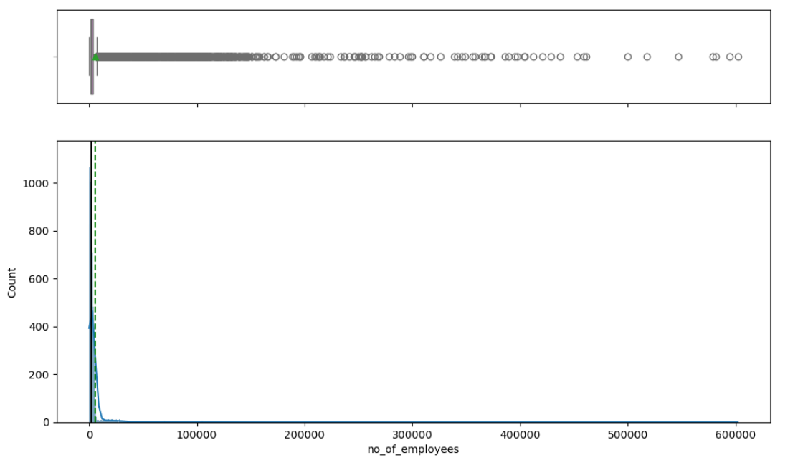
Figure 7: Box and Distribution plot
- The distribution of the number of employees is highly skewed to the right, meaning most companies have a small number of employees, but there are a few companies with a very large number of employees.
- There are many outliers in the dataset, representing these large companies.

5.2 Observations on prevailing_wage
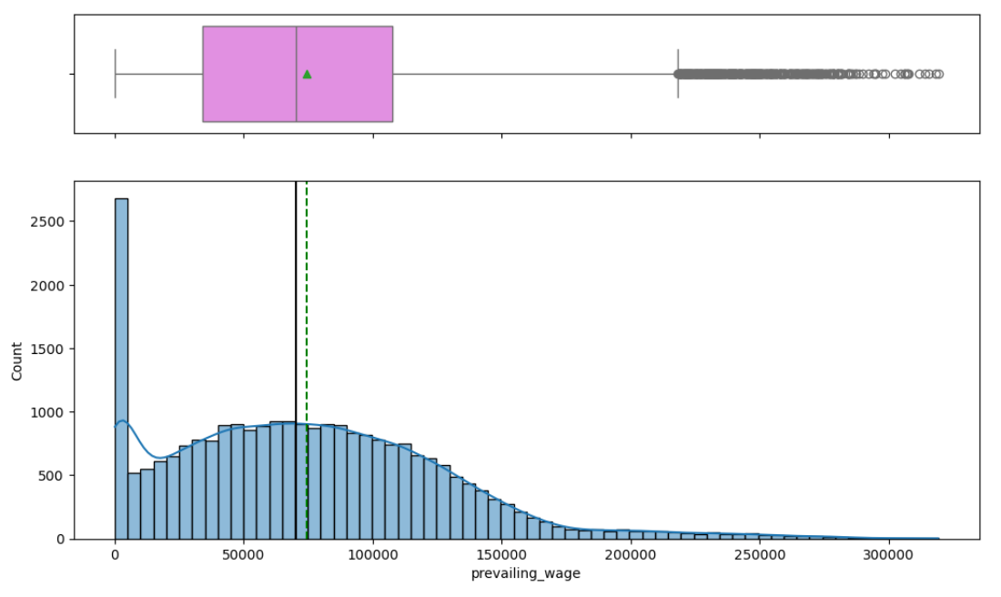
Figure 8: Box and Distribution plot

- The distribution of prevailing wages is highly right-skewed, meaning that most employees earn lower wages, while a few earn significantly higher wages.
- The dataset contains numerous outliers, suggesting that there are extreme wage values that deviate significantly from the central tendency.

5.3 Observations on continent
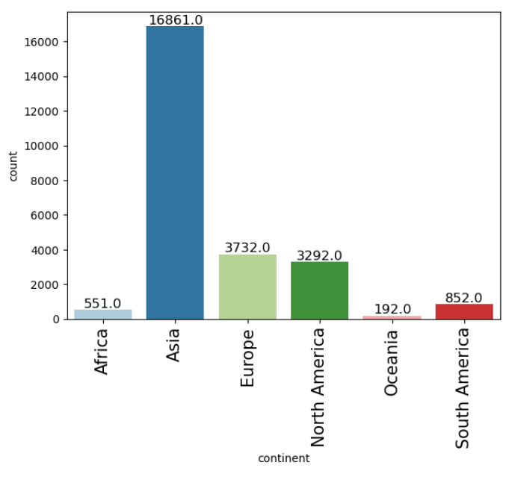
Figure 9: Count plot of continent attribute
- Asia has the highest count of data points at 16,861, indicating a significant concentration of data in this continent.
- Oceania has the lowest count at 192, suggesting that there are relatively fewer data points from this region.
- Other continents like Africa, Europe, and North America have moderate counts, with Europe and North America having similar values.

5.4 Observations on education_of_employee
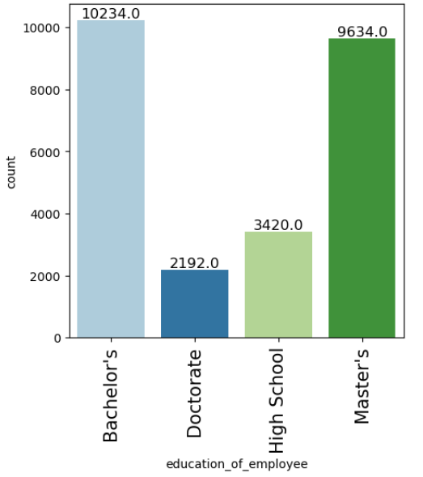
Figure 10: Count plot of education_of_emplyoee
- Most employees hold either a Bachelor's or a Master's degree.
- There are fewer employees with only a High School education, and even fewer with a Doctorate degree.

5.5 Observations on has_job_experience
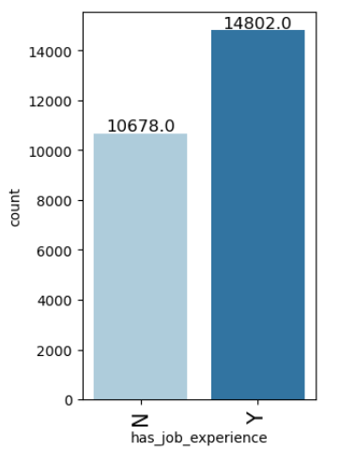
Figure 11: Count plot of attribute
- Most individuals in the dataset have job experience, with 14,802 cases falling into this category.
- A significant portion, 10,678 individuals, do not have job experience, but this number is lower compared to those with experience.

5.6 Observations on requires_job_training
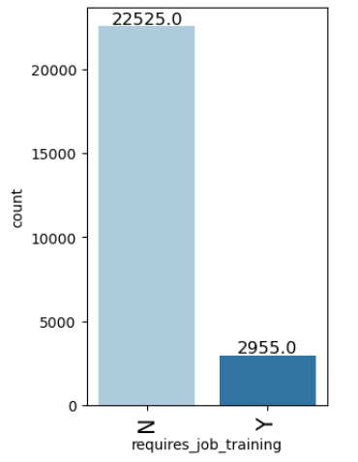
Figure 12: Count plot of attribute
- Most job positions do not require job training, as indicated by the higher count (22,525.0) in the "N" category.
- A smaller number of job positions (2,955.0) require training, highlighting that additional training is necessary for only a subset of job roles.7

5.6 Observations on region_of_employment
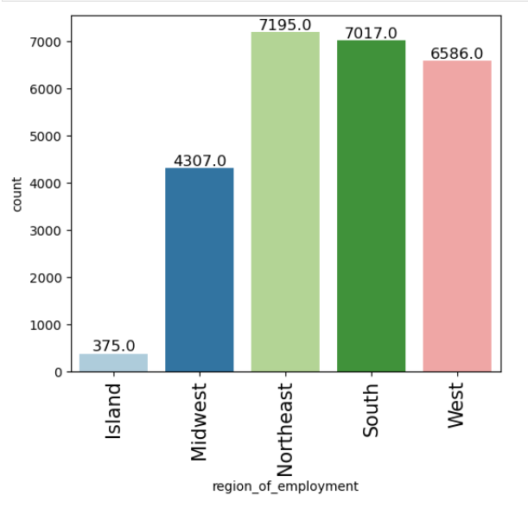
Figure 13: Count plot of attribute
- Northeast: This region has the highest count of employment at 7,195. This indicates that a significant portion of the employment data is concentrated in the Northeast region.
- South: Following closely behind, the South has a count of 7,017, also showing a strong presence of employment in this region.
- West: The West region has a substantial count of 6,586, indicating a significant employment presence.
- Midwest: The Midwest has a lower count compared to the Northeast, South, and West, with 4,307 cases.
- Island: The Island region has the lowest count of employment at 375, suggesting relatively fewer employment cases in this region.

5.7 Observations on unit_of_wage
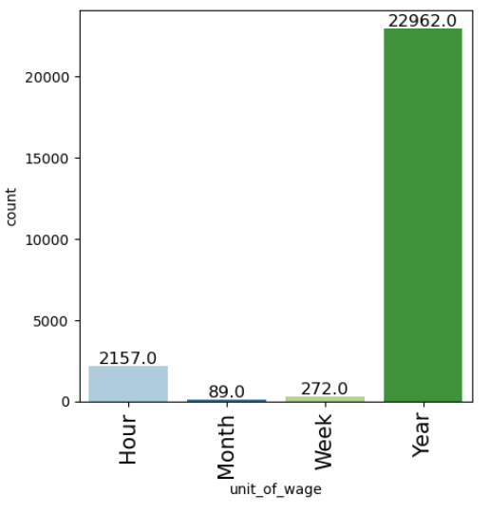
Figure 14: Count plot of attribute
- Most wages are measured on a yearly basis, with 22,962 cases. This indicates that most jobs offer annual salaries.
- The second highest count is for hourly wages, with 2,157 cases. This suggests that a notable number of jobs pay by the hour, but it is significantly less common than annual salaries.

5.8 Observations on full_time_position
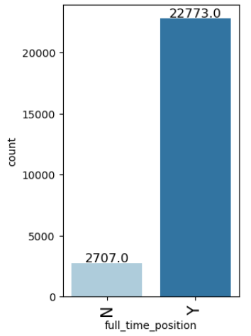
Figure 15: Count plot of attribute
- Most of the positions in the dataset are full-time, suggesting that full-time employment is the predominant work arrangement.
- The significantly lower count of non-full-time positions indicates that part-time or temporary roles are less common.

5.9 Observations on case_status
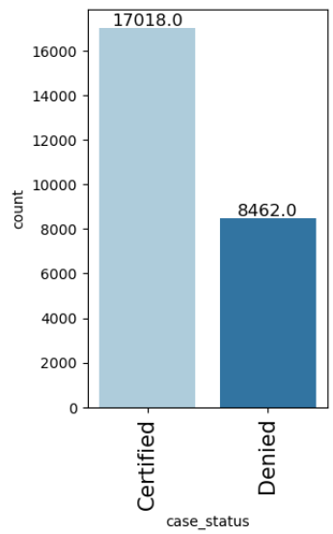
Figure 16: Count plot of attribute
- Most cases in the dataset were certified, suggesting that a higher proportion of applications met the required criteria for approval.
- There is still a significant number of denied cases, indicating that a notable portion of applications did not meet the necessary requirements.

6.0 Bivariate Analysis
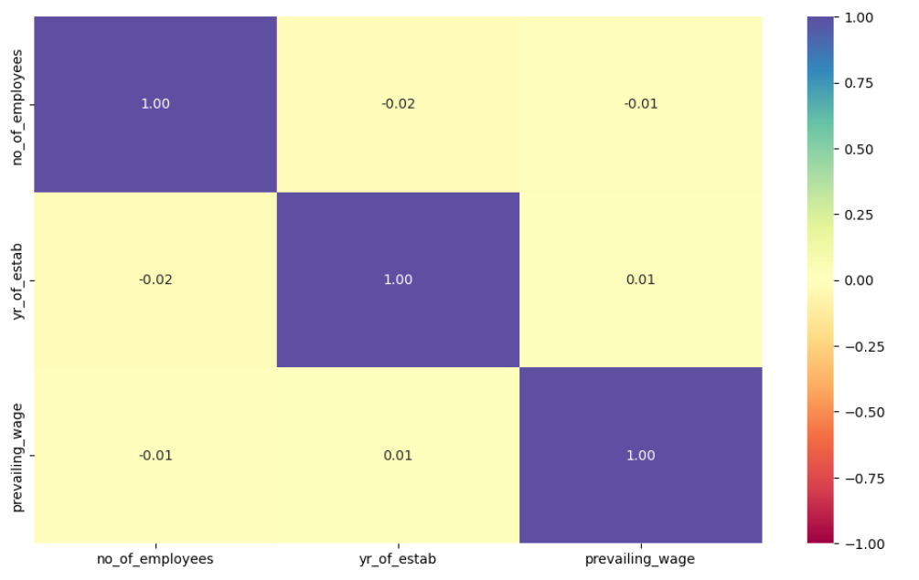
Figure 17: Heatmap of attributes

- The very weak correlations (ranging from -0.02 to 0.01) between "no_of_employees," "yr_of_estab," and "prevailing_wage" suggest that these variables do not have a significant linear relationship with each other in the dataset.
- The visualization helps in understanding that changes in one of these variables are not strongly associated with changes in the others.

6.1 Observations on case_status vs continent

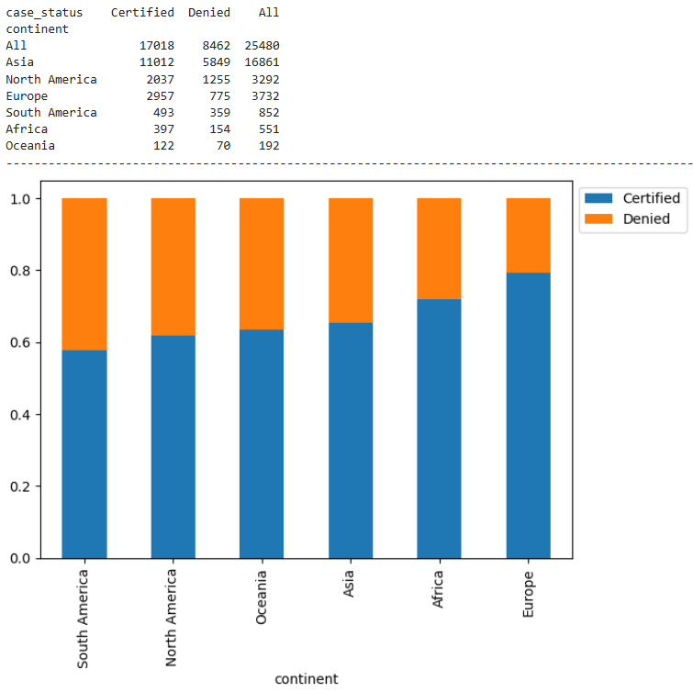
Figure 18: Count plot of attributes
- Overall Certification: Out of the total cases, the majority (17,018) were certified, indicating a higher approval rate.
- Asia: Asia has the highest number of total cases (16,861), with a majority being certified (11,012). However, it also has a significant number of denied cases (5,849).
- North America and Europe: Both continents have relatively high certification rates, with Europe having a higher proportion of certified cases compared to North America.
- South America, Africa, and Oceania: These continents have lower total case counts, with a majority being certified. South America and Africa have a notable number of denied cases, while Oceania has the least number of both certified and denied cases.

6.2 Observations on case_status vs education_of_employee

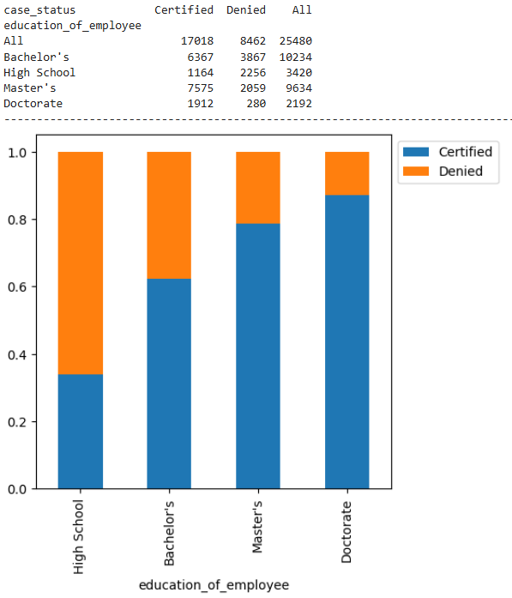
Figure 19: Count plot of attributes
- Certification Rate: The certification rate increases with higher education levels. High School has the highest denial rate, while Doctorate has the lowest denial rate.
- Bachelor's and Master's: The counts for Bachelor's and Master's degrees are relatively high, with a significant proportion of certified cases.
- High School: The denial rate is quite high for employees with only a High School education, indicating that higher education levels are more likely to get certified.
- Doctorate: Employees with a Doctorate degree have the highest certification rate and the lowest number of denials, suggesting that higher qualifications have a positive impact on certification.

6.3 Observations on case_status vs has_job_experience
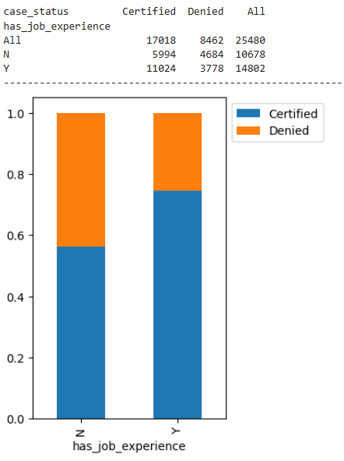
Figure 20: Count plot of attributes
- Certification Rate by Job Experience:
  - Applicants with job experience (Y) have a higher certification rate (11,024) compared to those without job experience (N), who have a lower certification rate (5,994).
  - This indicates that having job experience increases the likelihood of getting certified.
- Denial Rate by Job Experience:
  - Applicants without job experience (N) have a higher denial rate (4,684) compared to those with job experience (Y), who have a lower denial rate (3,778).
  - This suggests that lack of job experience increases the chances of application denial.
- Overall Counts:
  - The total number of cases is higher for applicants with job experience (14,802) compared to those without (10,678).

6.4 Observations on case_status vs requires_job_training
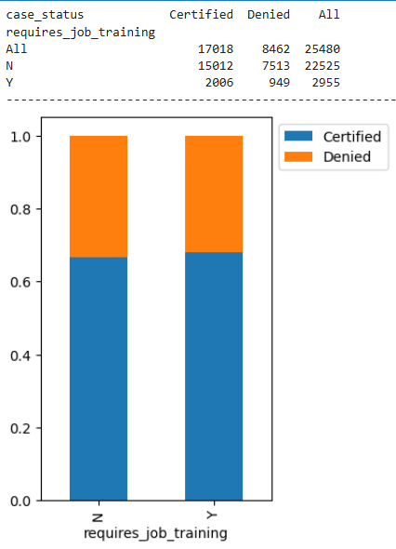
Figure 21: Count plot of attributes
- Certification Rate:
  - Jobs that do not require training (N) have a higher certification rate compared to those that do require training (Y). Out of 22,525 cases where no job training is required, 15,012 (approximately 67%) were certified.
  - In contrast, out of 2,955 cases where job training is required, 2,006 (approximately 68%) were certified.
- Denial Rate:
  - Jobs requiring no training (N) had 7,513 cases denied.
  - Jobs requiring training (Y) had 949 cases denied.
  - This suggests that most denied cases are for jobs that do not require training.
- Overall Distribution:
  - Most job cases do not require training (22,525), compared to the smaller number of cases that require training (2,955).
  - Both categories (N and Y) have a higher proportion of certifications than denials, indicating an overall tendency towards case approval.

6.5 Observations on case_status vs no_of_employees
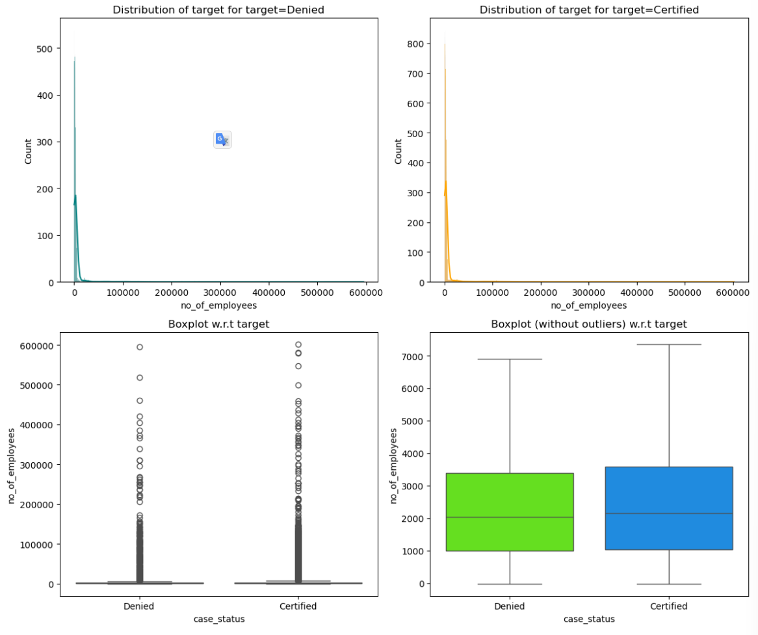
Figure 22: Box and Distribution plot of attributes
- Most of the cases, whether denied or certified, involve companies with a smaller number of employees.
- There are a few larger companies with a high number of employees, but they are outliers in the dataset.
- The central tendency (median) is similar for both denied and certified cases, suggesting that company size alone may not be a significant differentiator for case status.

6.5 Observations on case_status vs yr_of_estab
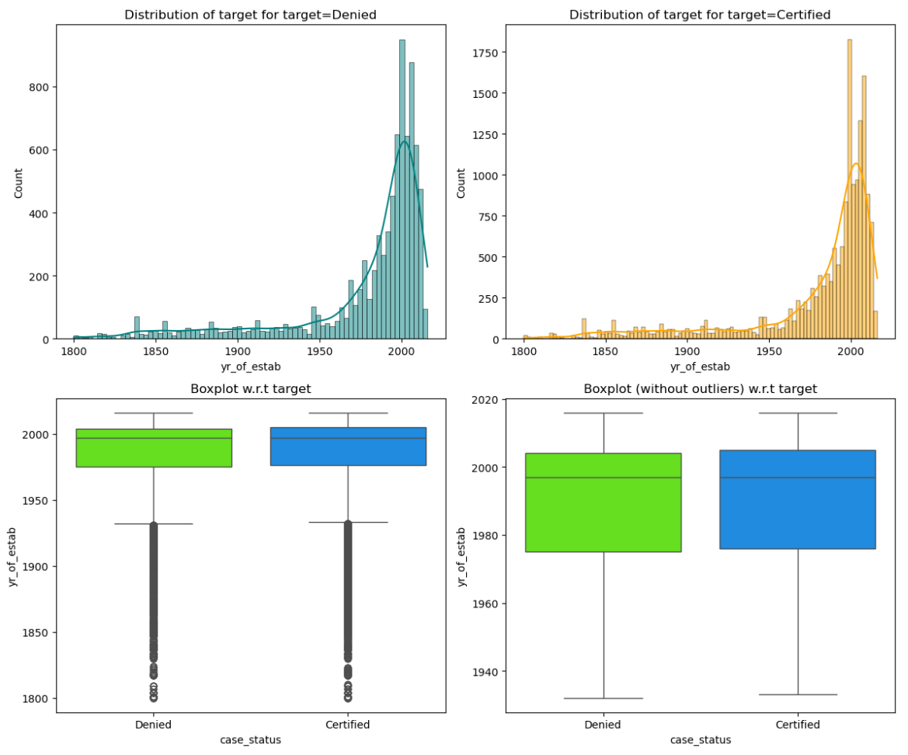
Figure 23: Box and Distribution plots of attributes
- Both denied and certified cases show an increasing trend over time, with a peak around the year 2000.
- The median year of establishment for both denied and certified cases is similar, around the year 2000.
- The interquartile range is also similar for both denied and certified cases, indicating that the year of establishment is not a significant differentiator for case status.
- The presence of outliers in the bottom-left boxplot suggests there are some cases with an unusual year of establishment, but the overall trend remains consistent.

6.5 Observations on case_status vs region_of_employment
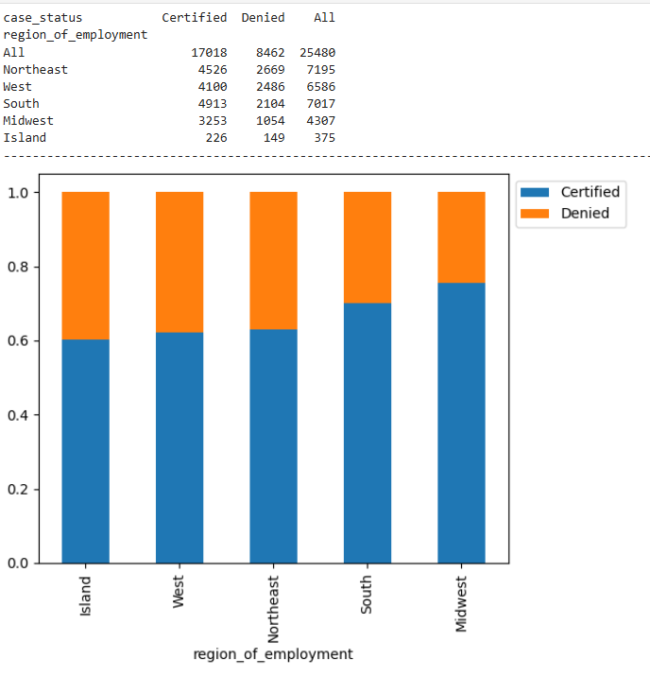
Figure 24: Count plot of attributes
- Northeast: This region has the highest count of employment cases (7,195), with a significant number of certified cases (4,526) and denied cases (2,669).
- West: The West region has a considerable number of employment cases (6,586), with more certified cases (4,100) than denied cases (2,486).
- South: The South region also has a high count of employment cases (7,017), with a majority being certified (4,913) and a smaller number being denied (2,104).
- Midwest: The Midwest has a moderate count of employment cases (4,307), with more certified cases (3,253) compared to denied cases (1,054).
- Island: The Island region has the lowest count of employment cases (375), with a majority being certified (226) and a smaller number being denied (149).

6.6 Observations on case_status vs prevailing_wage
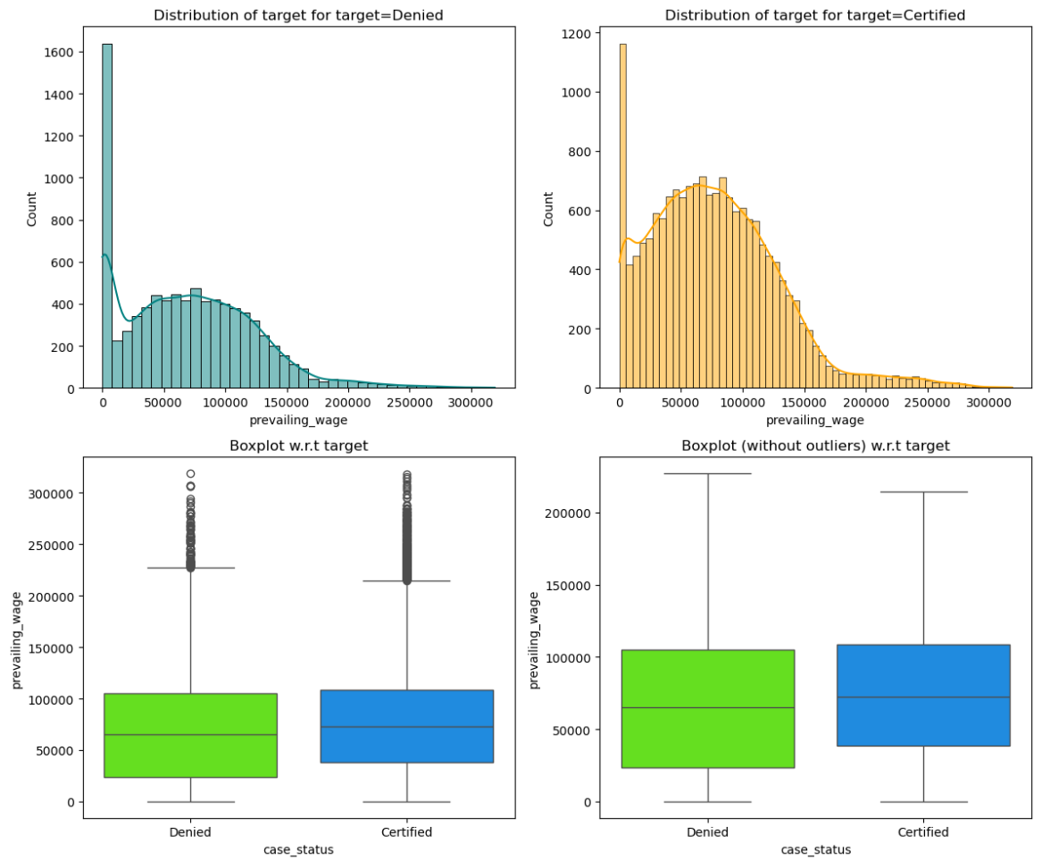
Figure 25: Box and Distribution plots of attributes
- Both the denied and certified cases show a right-skewed distribution of prevailing wages, with most cases concentrated at lower wage values.
- The boxplots indicate that the median prevailing wage is similar for both denied and certified cases.
- The presence of outliers in the bottom left plot suggests there are extreme wage values in the dataset.

6.7 Observations on case_status vs unit_of_wage
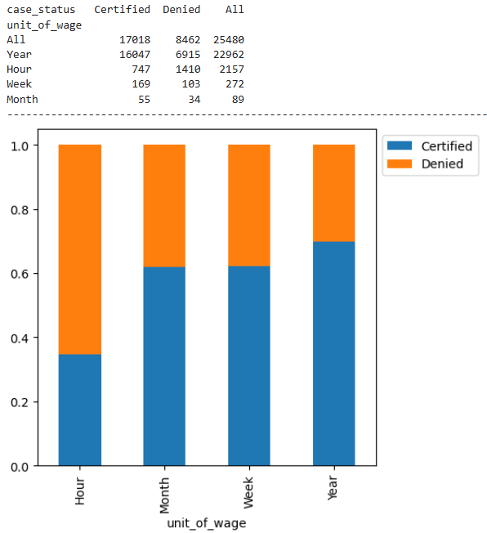
Figure 26: Count plot of attributes
- Year: Many cases (22,962) use "Year" as the unit of wage. Among these, 16,047 are certified, and 6,915 are denied. This indicates that annual wages are the most common and have a high certification rate.
- Hour: There are 2,157 cases using "Hour" as the unit of wage, with 747 certified and 1,410 denied. This suggests that hourly wages are less common and have a higher denial rate.
- Week: There are 272 cases using "Week" as the unit of wage, with 169 certified and 103 denied. Weekly wages are relatively rare but have a decent certification rate.
- Month: There are 89 cases using "Month" as the unit of wage, with 55 certified and 34 denied. Monthly wages are the least common and have a moderate certification rate.

6.8 Observations on case_status vs full_time_position
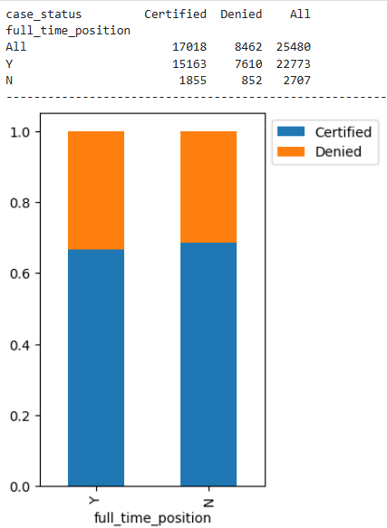
Figure 27: Count plot of attributes
- Full-Time Positions (Y): Many cases (22,773) are for full-time positions. Among these, 15,163 are certified, and 7,610 are denied. This indicates that full-time positions have a high certification rate.
- Non-Full-Time Positions (N): There are 2,707 cases for non-full-time positions, with 1,855 certified and 852 denied. Although the numbers are smaller, the certification rate is still relatively high.

7.0 Data Preprocessing

7.1 Feature Engineering

7.1.1 Dealing with Ordinal data point education_of_employee

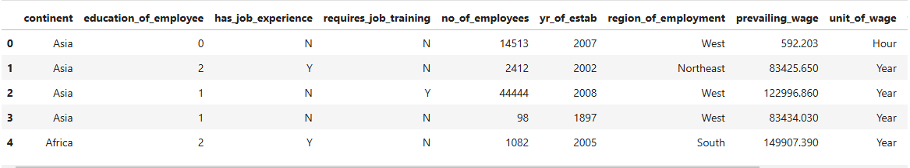
Figure 28: education of employee feature engineering

7.1.2 adding a derived feature named Company Age from yr_of_estab
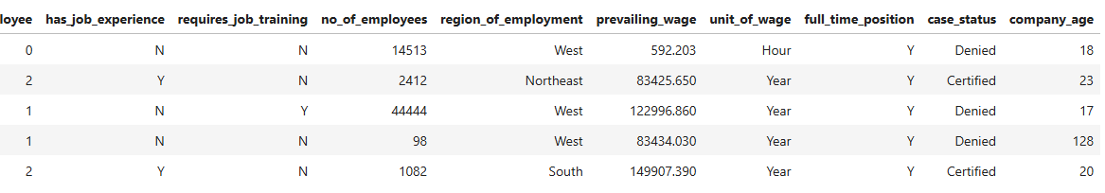
Figure 29: Adding a derived feature.

7.2 Checking for Outliers

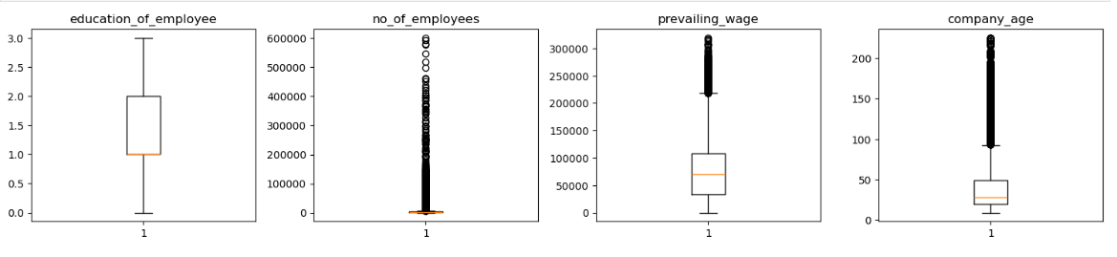
Figure 30: Checking for outliers
Each of the 4 numerical attributes contain outliers but these are real values which are true in nature in Realtime. So, treating them would be manipulating the data which in turn effects the model performance.

7.3 Data Split into Train, Validation, Test sets.
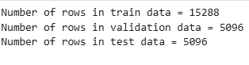
Figure 31: Data split

7.4 Encoding Categorical variables.
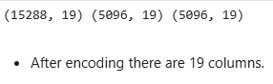
Figure 32: One hot encoding of categorical variables

8.0 Model Building

Model evaluation criterion
Model can make wrong predictions as:
Predicting an applicant will get visa approved, the good applicant is Certified
Predicting the bad applicant is Certified will have negative impact on model.
Which case is more important?
Predicting an applicant whose profile is bad but the model predicted as certified will impact the visa process.
How to reduce this loss i.e., need to reduce False Negatives?
OFLC would want Recall to be maximized, greater the Recall lesser the chances of false negatives.

8.1 Model Performance – Original Data
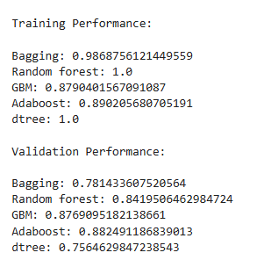
Figure 33: Training data and Validation data Performance on Original Data

8.1.1 Training and Validation Performance Difference: Original Data
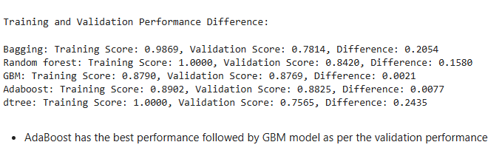
Figure 34: Difference between Performances

8.2 Model Performance – Oversampled Data

8.2.1 Oversampled Data Shape and Description
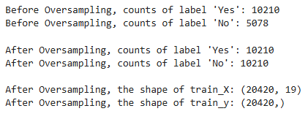
Figure 35: Oversampled Data Shape and Description
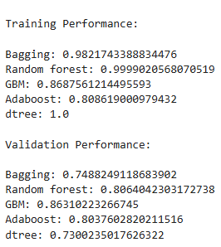
Figure 36: Training data and Validation data Performance on Oversampled Data

8.2.1 Training and Validation Performance Difference: Oversampled Data
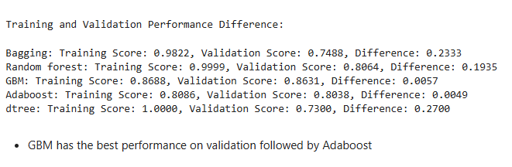
Figure 37: Difference between Performances

8.3 Model Performance – Undersampled Data

8.3.1 Undersampled Data Shape and Description

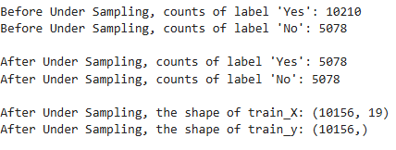
Figure 38: Undersampled Data Shape and Description
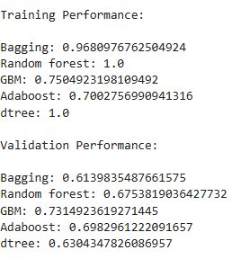
Figure 39: Training data and Validation data Performance on Undersampled Data

8.3.1 Training and Validation Performance Difference: Undersampled Data

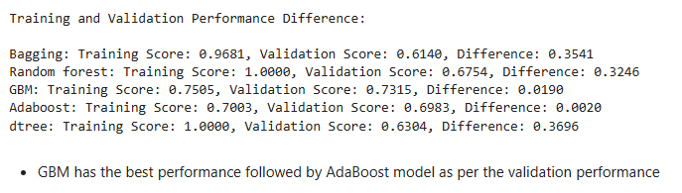
Figure 40: Difference between Performances

8.4 Model Choosing Stage for Hyperparameter Tuning

After building 15 models, it was observed that both the GBM and Ada boost models, trained on an Original dataset, as well as the GBM model trained on an oversampled dataset, exhibited strong performance on both the training and validation datasets.

9.0 Hyperparameter Tuning

9.1 Tuning Ada Boost Classifier model with Original data

9.1.1 Tuned Model Performance on Train and Validation Dataset

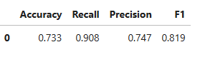
Figure 41: Tuned Model Performance on Training data
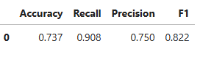
Figure 42: Tuned Model Performance on Validation data
After Tuning Recall Score has increased from 89% to 90%.

9.2 Tuning Gradient Boosting classifier model with Original data

9.2.1 Tuned Model Performance on Train and Validation Dataset

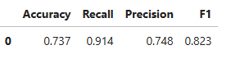
Figure 43: Tuned Model Performance on Training data
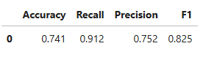
Figure 44: Tuned Model Performance on Validation data
After Tuning Recall Score has increased from 87% to 91%.

9.3 Tuning Gradient Boosting classifier model with Oversampled data

9.3.1 Tuned Model Performance on Train and Validation Dataset

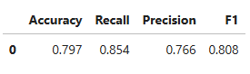
Figure 45: Tuned Model Performance on Training data

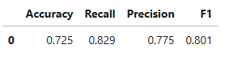
Figure 46: Tuned Model Performance on Validation data

After Tuning there is no much change in Recall Score.

10.0 Model Comparison and Final Model Selection

10.1 Training data Performance Comparison

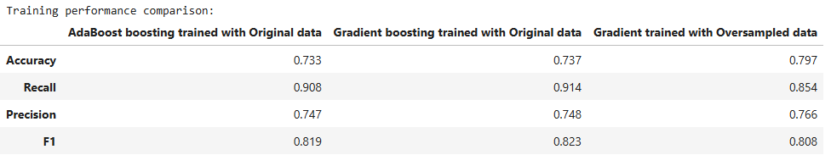
Figure 47: Model Comparison on Training Data
the Gradient Boosting model trained with original data achieves the highest recall and F1 score, indicating a strong performance in correctly identifying true positives and maintaining a balance between precision and recall.

10.2 Validation data Performance Comparison
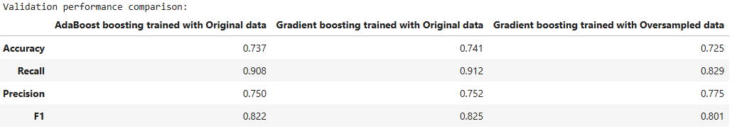
Figure 48: Model Comparison on Validation Data
The Gradient Boosting model trained with original data generally performs the best across most metrics (Accuracy, Recall, and F1 score), making it a strong candidate for further evaluation.

10.3 Test data Performance Comparison using selected Model

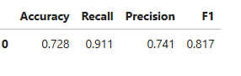
Figure 49:Final Performance on Test Data
- The Gradient boost model trained on Original data has given ~91% recall on the test set
- This performance is in line with what we achieved with this model on the train and validation sets
- So, this is a generalized model

11.0 Feature Importance

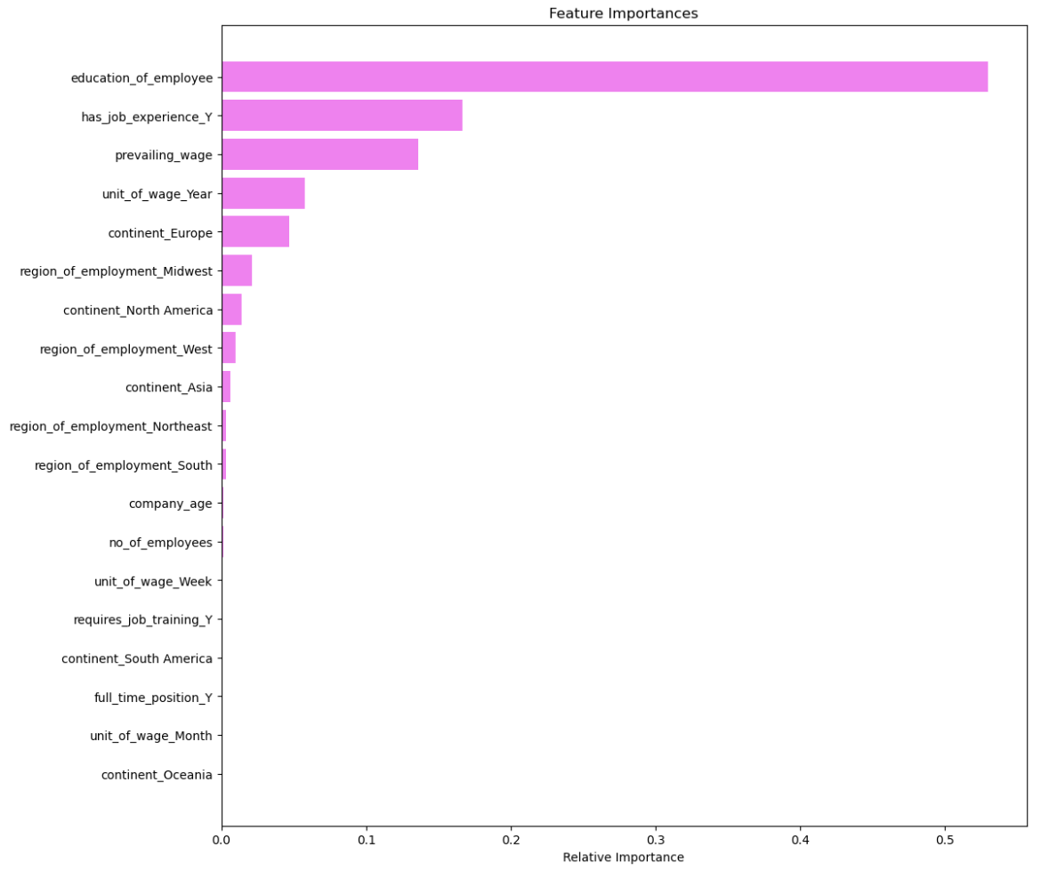
Figure 50: Feature Importance

- Top Features: The education level of employees, job experience, and prevailing wage are the most important features in the model. These factors significantly influence the predictions.
- Geographical Factors: Continent and region of employment also play a role in the model's decisions, with Europe and the Midwest having higher importance compared to other regions.
- Wage Units: The unit of wage (Year, Week, Month) has varying importance, with annual wages being more significant.
- Other Factors: Company age, number of employees, and job training requirements have lower importance but still contribute to the model's predictions.

12.0 Business Insights and Recommendations

1. Education of Employee:
Insight: Higher education levels significantly increase the likelihood of visa approval.
Recommendation: Encourage applicants to highlight their highest educational qualifications and consider partnering with educational institutions to attract highly qualified candidates.
2. Job Experience:
Insight: Applicants with prior job experience have a higher chance of visa approval.
Recommendation: Emphasize the importance of relevant job experience in the application process. Provide resources or training to help applicants gain relevant experience before applying.
3. Prevailing Wage:
Insight: Higher prevailing wages correlate with higher approval rates.
Recommendation: Ensure that wages offered are competitive and meet or exceed industry standards. Highlight the offered wage in the application to strengthen the case.
4. Unit of Wage:
Insight: Yearly wages are preferred.
Recommendation: Whenever possible, offer wages on a yearly basis to increase the likelihood of visa approval. Clearly specify the yearly wage in the application.
5. Continent of Origin:
Insight: Applicants from specific continents, such as Europe, have different approval rates.
Recommendation: Tailor recruitment strategies based on the continent of origin. For example, target regions with higher approval rates for sourcing talent.
6. Region of Employment:
Insight: The intended region of employment within the US affects approval chances.
Recommendation: Focus on regions with higher demand for foreign workers and higher approval rates. Provide guidance to applicants on selecting regions with better approval prospects.

7. Full-Time Position:
Insight: Full-time positions have higher approval rates compared to part-time positions.
Recommendation: Whenever possible, offer full-time positions to increase the likelihood of visa approval. Clearly specify the full-time nature of the position in the application.
8. Company Age:
Insight: Older, more established companies have higher approval rates.
Recommendation: Highlight the stability and reputation of the employer's company in the application. For newer companies, provide additional documentation to demonstrate stability and growth potential.
9. Number of Employees:
Insight: Larger companies tend to have higher approval rates.
Recommendation: Highlight the size and resources of the employer's company to strengthen the application. Smaller companies can focus on showcasing their growth trajectory and resource management.

